**DAILY ONLINE ACTIVITIES SUMMARY**

|  |  |  |  |  |  |  |  |  |
| --- | --- | --- | --- | --- | --- | --- | --- | --- |
| **Date:** | **23-05-2020** | | | | | **Name:** | **Preethi** | |
| **Sem & Sec** | **6th - B** | | | | | **USN:** | **4AL17CS065** | |
| **Online Test Summary** | | | | | | | | |
| **Subject** | | **Python Application Program** | | | | | | |
| **Max. Marks** | | **30** | | **Score** | | | **19** | |
| **Certification Course Summary** | | | | | | | | |
| **Course** | **Introduction to Ethical hacking** | | | | | | | |
| **Certificate Provider** | | | **greatlearning** | | **Duration** | | | **6 hours** |
| **Coding Challenges** | | | | | | | | |
| **Problem Statement: 1 C program** | | | | | | | | |
| **Status: executed** | | | | | | | | |
| **Uploaded the report in GitHub** | | | | | **Yes** | | | |
| **If yes Repository name** | | | | | https://github.com/PreethiNayak/Daily-Status | | | |
| **Uploaded the report in slack** | | | | | **Yes** | | | |

Online Test Details: (Attach the snapshot and briefly write the report for the same)

First I A of PAP

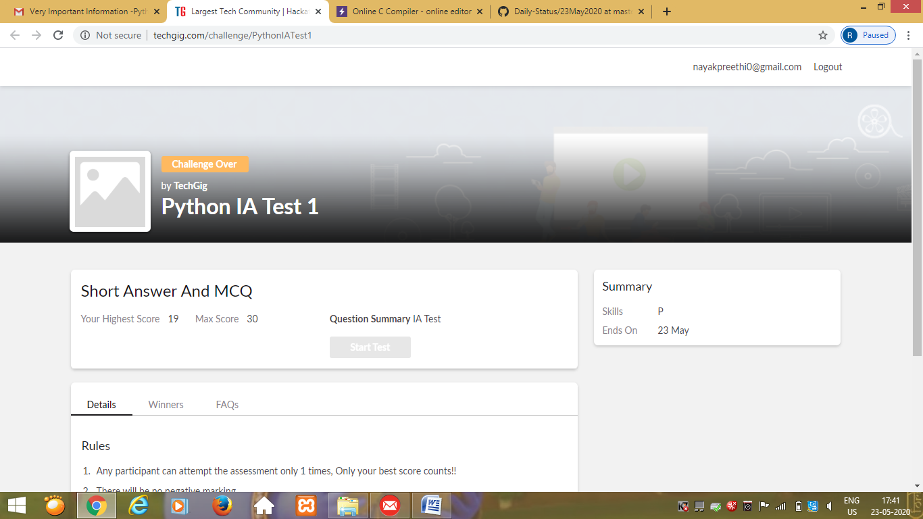

Certification Course Details: (Attach the snapshot and briefly write the report for the same)

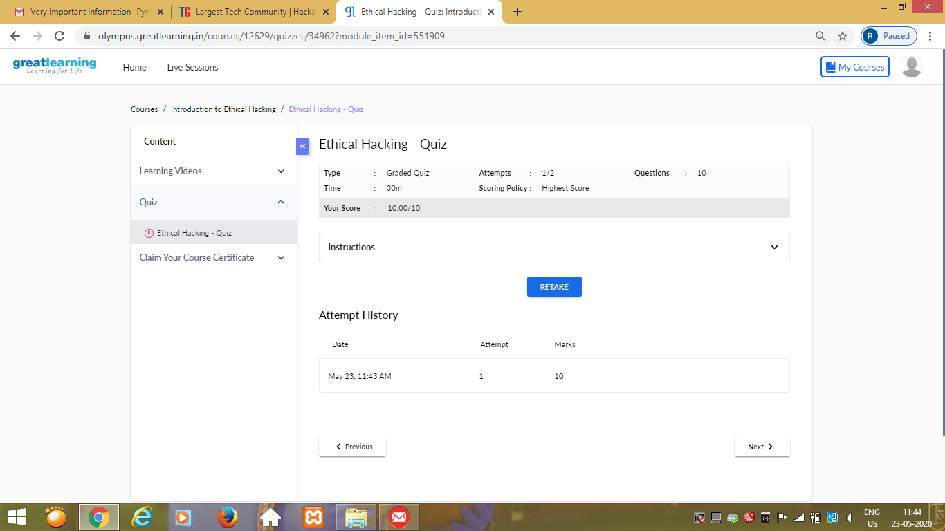

Coding Challenges Details: (Attach the snapshot and briefly write the report for the same)

OUTPUT SCREEN-SHOTS

Program 1

